Alex and Rebecca’s Wedding Saturday 17th July 2010
We do hope that you’ll be able to join us on the 17th. Please RSVP to rsvp@jackoandjonesy.com including any special dietary requirements. If you’ve got any other questions then please get in touch via email: alexandrebecca@jackoandjonesy.com or telephone Alex (07801 342220) or Rebecca (07731 667374).
Directions and Travel
Like many things in Devon, traffic moves slowly and during July it can often take over an hour to reach Torquay from the Penn Inn roundabout in Newton Abbot. So please allow plenty of time for your journey, especially if you are travelling on the Saturday.
By Car: From M5 J31 follow the A38 to Plymouth. After 2 miles bear onto the A380 towards Newton Abbot. Continue past Newton Abbot and through Kingskerswell. At the roundabout follow the A3022 Riviera Way towards Torquay town centre. After a mile, Torre station and Halfords on the right, the road forks at a set of lights:
For the Grand Hotel bear right along Avenue Road, continuing until you reach the sea front, then turn right (sign posted A3022 Paignton) then almost immediately right again into Rathmore Road. The hotel is on your left opposite Torquay train station.
For the Church/Town Centre bear left along Newton Road and follow the one way system round to the right into South Street (Quick Cabs on the left). Continue along South Street, becoming Belgrave Road, then turn left at the Belgravia Hotel into Lucius Street, becoming Tor Church Road. Turn right at the Central Church into Abbey Road, continuing straight on and the multi-storey car park is on your left (where the road becomes one way) with the church a little further along on the right. For the Church car park (very limited number of spaces) turn right at the lights/bollards into St Luke’s Road/Shedden Hill Road then second left into Warren road (St Luke’s church on the left) following the road all the way round in a loop. Our Lady of the Assumption is on the left just before you reach Abbey Road and the multi-storey is now back up the Abbey Road hill on your right.
By train: Trains from go from Paddington to Newton Abbot (3 to 4 hours) then change for Torquay (10 mins). The Grand Hotel is immediately opposite the station. For the centre of town head along the sea front or up Rathmore road.
Walking/Cycling: From the Grand Hotel (to the church) walk along the seafront with the beach on your right. Turn left up Shedden Hill Road past the Premier Inn on your left. Continue up the hill and bear round to the left passing the Shedden Hall Hotel on the left and St Luke’s Church on the right. At the traffic lights turn right into Abbey Road and the Church is on your right.
Taxis: Torbay Taxis: 01803 211 611 Price First Taxis: 01803 322 322 Babbacombe Cars: 01803 326 450
Church
Our Lady of the Assumption, 76 Abbey Road, Torquay, Devon, TQ2 5NJ. There is limited parking available in front of the church and if you are driving we recommend you use the multi-storey car park 97 Abbey Rd, Torquay TQ2 5PJ. If you are struggling for a lift to/from the church then please let us know.
Reception
The Grand Hotel, Torquay, TQ2 6NT (01803) 296 677. For hotel guests there is limited parking at the Grand Hotel, in the garage or allocated spaces in the station car park with additional parking at the Rugby club, TQ2 6NX‎ (please ask at reception for details). For hotel non-residents there is street parking or Torre Valley Car Park, TQ2 5JY
Accommodation
If you haven’t got this sorted yet then visit www.jackoandjonesy.com/accommodation.html
Timings and Logistics
The church is a 15 to 20 minute walk from the Grand Hotel and the service starts at 12pm lasting approximately one hour. Drinks and canapés will be offered at the Grand from 1pm followed by a wedding breakfast from 2.30pm until 6, with the evening party from 7pm until 1am.
Gift List
Your company alone will be sufficient but if you would like to buy us a present we have a wedding list with www.johnlewisgiftlist.com number 413868.
Things to do in Devon
For a list of ideas of things to do in and around Torquay see www.jackoandjonesy.com/thingstodo.html.
Map
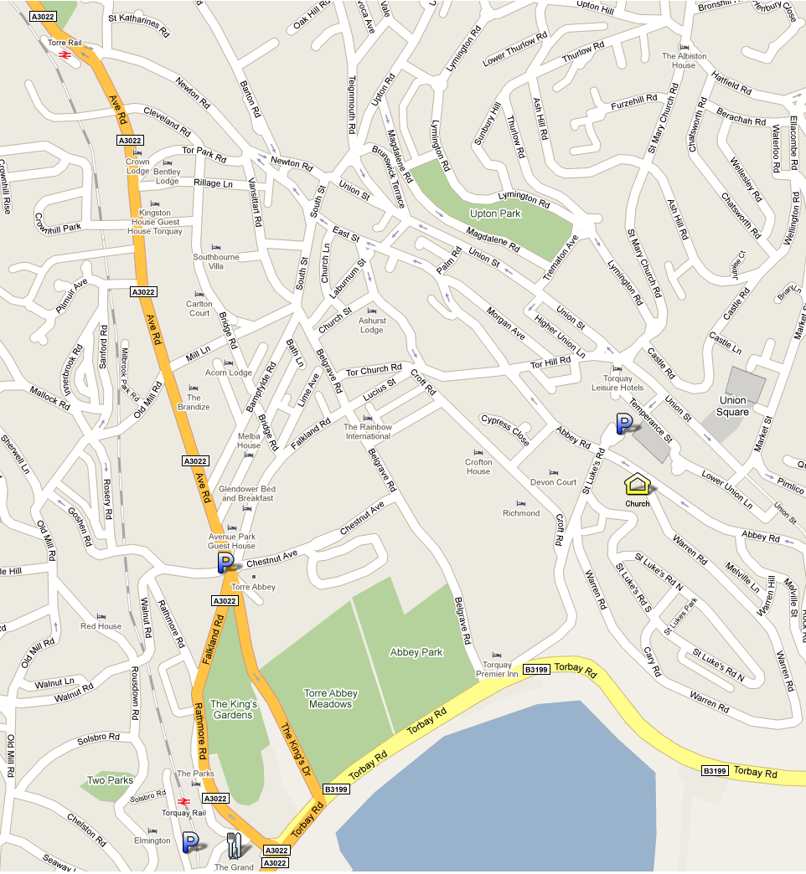

For the latest information www.jackoandjonesy.com/details.html or download this document www.jackoandjonesy.com/details.doc.

